EarlySign: Multimodal Behavioral and Biological Biomarkers for Early Autism Risk Prediction
Harnesh G, Kishore R, Dharun Kumar R, Ms. P. Janani
Department of Computer Science and Engineering (AI), VISTAS, Chennai, India
Abstract—Autism spectrum disorder (ASD) is often identified later than it could be, and each month of delay is a month without early support for the child. Clinical assessment is thorough, but it is slow and depends on a small pool of specialists. In this paper we ask a practical question: can several early signs, recorded with whatever tests a clinic has, be combined into one clear risk level that tells a clinician which toddlers to assess first? We present EarlySign, a browser-based tool that combines up to eight modules (a 20-item M-CHAT-style parent questionnaire, eye tracking, EEG, MRI, blood markers, genetic results, speech and motor skills) into an ASD risk level of Low, Medium or High. Three scoring methods are compared: a transparent weighted score, logistic regression and a depth-3 decision tree, each with a per-module explanation. On a held-out set of 90 simulated children, the weighted score reached the best AUC (0.892), while logistic regression gave the best accuracy (90.0%), F1-score (76.9%) and sensitivity at the High cut-off (62.5%) with no false positives. The tool is meant to help clinicians decide whom to evaluate first; it is not a replacement for clinical diagnosis, and all results so far come from simulated data.
Keywords—autism spectrum disorder, early screening, multimodal biomarkers, explainable machine learning, logistic regression, decision tree.

I. INTRODUCTION
Autism spectrum disorder (ASD) is a neurodevelopmental condition marked by differences in social communication and by restricted, repetitive patterns of behavior [1]. Signs usually appear in early childhood, and reported prevalence has kept rising; the most recent US surveillance estimate, for 2020, is about 1 in 36 children aged eight [2]. ASD is now widely regarded as a public health concern rather than a narrow clinical topic.
Timing matters a great deal. Support that begins early tends to lead to better long-term outcomes, yet in practice a diagnosis is often made only after a child turns three or four. Part of the delay comes from how diagnosis works. It rests on specialist observation and structured clinical scales, which take time, involve a degree of subjectivity, and need experienced clinicians who are in short supply [3]. Families in low-resource regions feel this gap most sharply.
Short screening questionnaires were introduced to ease that pressure. The M-CHAT-R/F, for example, is a parent-completed checklist for toddlers that sorts children into risk levels using fixed score cut-offs [4]. Such tools are valuable, but a fixed cut-off cannot learn from data: it cannot tell us which behaviors are the most informative, or how they interact.
Another line of research has turned to brain signals and gaze. Han et al., for instance, recorded EEG and eye-tracking data from 90 children and fused them with deep networks, reaching more than 95% accuracy [5]. Results like these are encouraging, but they depend on laboratory-grade equipment and trained operators, which puts them out of reach for a village clinic or a preschool screening drive. Behavioral information, in contrast, costs almost nothing to collect.
This work asks whether several early signs, each available in some clinics but rarely all together, can be combined into one explainable ASD risk level. Our contributions are:
- EarlySign, a single-file web tool that scores any subset of eight biomarker modules and reports how much data each score is based on.
- A side-by-side comparison of a weighted score, logistic regression and a decision tree, judged with particular attention to sensitivity.
- A per-module explanation of every score, so that predictions can be read and checked by clinicians.
The remainder of the paper is organized as follows. Section II reviews related work, Section III describes our method, Section IV presents the results, Section V discusses them, and Sections VI and VII cover limitations and conclusions.
II. RELATED WORK
EEG is inexpensive compared with other neuroimaging techniques, and many studies have used it to look for differences between children with ASD and typically developing (TD) children. Wadhera and Kakkar trained an SVM on graph-based EEG measures and reported 92.34% accuracy [6], while Baygin et al. passed EEG signals through pre-trained networks to obtain deep features and reached 96.44% with an SVM classifier [7]. Eye tracking studies behavior instead of brain activity. Liu et al. classified children from their gaze in a face-recognition task, with a best accuracy of 88.51% [8], and Wan et al. reached 85.1% using only how long children fixated on a short video of a woman speaking [9].
The study closest to ours in spirit, and the one that motivated this work, is by Han et al. [5]. They recorded resting-state EEG and task-based eye-tracking data from 40 children with ASD and 50 TD children aged 3 to 6 years. From the EEG they computed spectral power, multiscale entropy and brain-network measures (125 features in all), and from the eye tracker they took fixation-based indicators over eight areas of interest (96 features). Each modality was first compressed by its own stacked denoising autoencoder, and a third autoencoder then fused the two learned representations. Under 10-fold subject-independent cross-validation the fused model reached 95.56% accuracy, 92.5% sensitivity and 98% specificity. Single-modality models did clearly worse (81.11% for EEG and 86.67% for eye tracking), and even a plain concatenation of the two feature sets gave 93.33%, which suggests that combining complementary views of the child is what pays off. The authors also admit two drawbacks: both recordings must be available at the same time, and training three networks is computationally heavy.
TABLE I. SELECTED STUDIES ON ASD IDENTIFICATION (ACCURACY AS REPORTED)
Study | Modality | Method | Acc. (%)
Wadhera & Kakkar [6] | EEG | Graph features + SVM | 92.34
Baygin et al. [7] | EEG | Deep features + SVM | 96.44
Liu et al. [8] | Eye tracking | ML on face-processing gaze | 88.51
Wan et al. [9] | Eye tracking | LDA on fixation time | 85.1
Han et al. [5] | EEG + eye tracking | SDAE-based fusion | 95.56
This work | Multimodal (8 modules, simulated) | Weighted / LR / tree | 84.4–90.0
Note: the studies use different datasets and protocols, so the figures are not directly comparable.
Clinical practice leans heavily on behavioral information. Even in the study above, children were characterized through parent- or teacher-reported instruments such as the Autism Behavior Checklist, the Social Communication Questionnaire and the Social Responsiveness Scale, because reliable clinical records were hard to obtain at the school site [5]. Screening instruments such as the M-CHAT-R/F [4] follow the same logic: they ask about everyday behaviors and translate the answers into a risk category. What these instruments do not do is learn from data.
That gap is where our work sits. Instead of requiring every recording at once, as fusion models do [5], EarlySign accepts whatever subset of signals a clinic has, from a free parent questionnaire up to EEG and MRI, and lets a trained model or a transparent weighting decide how to combine them.
III. METHODOLOGY
A. Overview
Fig. 1 outlines the pipeline. A child profile and any of eight biomarker modules are entered, each measure is normalised, module sub-scores are computed, three scoring methods combine them, and the result is reported as a risk level with an explanation.
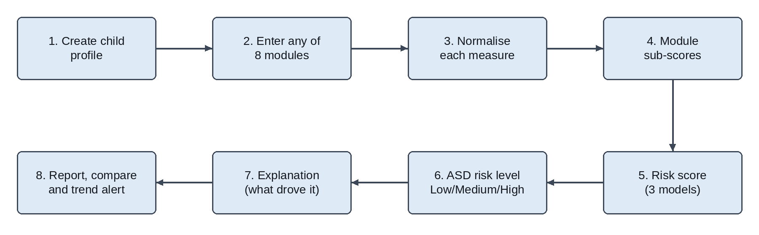
Fig. 1. Workflow of the EarlySign ASD risk prediction framework.
B. Data
Since no consented clinical data was available to us, the data come from a simulator built into EarlySign. It generates 300 children aged 12 to 36 months with a fixed random seed, of whom 85 (28%) are labeled ASD and 215 non-ASD. Each record holds 20 binary questionnaire answers and 23 numeric measures across eye tracking (3), EEG (4), MRI (3), blood (5), genetic (polygenic score and a variant flag), speech (3) and motor (3). For ASD-labeled children a random severity shifts each measure towards risk, and 25% of the non-questionnaire modules are dropped at random to mimic missing clinic tests. The target is the simulated ASD / non-ASD label.
C. Normalisation and Sub-scores
Each measure is converted to a z-score against a placeholder reference mean and standard deviation and signed so that positive means further towards risk. The z-scores of a module are averaged and passed through a logistic curve to give a sub-score between 0 and 1; the questionnaire is scored from the count of risk answers, and a reported high-impact variant sets the genetic sub-score to at least 0.85. A missing module is set to a neutral 0.5 for the learned models and left out of the weighted score.
D. Scoring Methods
We compared three methods that suit a small, tabular, partly missing dataset. The weighted score is the weighted average of the completed modules (behaviour 25%, eye tracking 18%, EEG 12%, MRI 10%, genetic 10%, speech 10%, motor 8%, blood 7%) plus 5 points for a sibling with ASD and 3 for other family history. Logistic regression learns one weight per module and is trained in the browser by gradient descent (2,000 epochs, L2 penalty 0.002); its contributions are exact Shapley values. The decision tree uses CART with Gini impurity, a maximum depth of 3 and at least 10 children per leaf. All three run in JavaScript inside the browser, with no server.
E. Evaluation Protocol
The first 210 children were used for training and the remaining 90 (24 labeled ASD) were held out for testing. We treat ASD as the positive class and report accuracy, precision, sensitivity (recall), specificity, F1-score and the area under the ROC curve (AUC). With TP, TN, FP and FN denoting true positives, true negatives, false positives and false negatives, the first four are defined as:
Accuracy = (TP + TN) / (TP + TN + FP + FN) (1)
Precision = TP / (TP + FP) (2)
Sensitivity = TP / (TP + FN) (3)
Specificity = TN / (TN + FP) (4)
The F1-score is the harmonic mean of precision and sensitivity. Scores of 0.60 or more are labeled High and scores from 0.35 to 0.59 Medium. In a screening setting we pay particular attention to sensitivity, because missing a child who needs assessment is generally more costly than an extra referral, so we report results at both cut-offs.
F. Explanation
Each method explains itself differently: the weighted score through each module's share of the total, logistic regression through its learned weights and per-child Shapley values, and the decision tree through the path a child takes and the change in risk at each split.
IV. EXPERIMENTAL RESULTS
A. Classification Performance
Table II lists the hold-out performance at the High cut-off. Logistic regression gave the best accuracy (90.0%), F1-score (76.9%) and sensitivity (62.5%), with no false positives. The weighted score had the best AUC (0.892) but was the most cautious at High, flagging only 10 of 24 ASD-labeled children. At the Medium cut-off its sensitivity rose to 87.5% (21 of 24) at a specificity of 74.2%, while logistic regression reached 66.7% sensitivity and 97.0% specificity, and the decision tree 70.8% and 92.4%.
TABLE II. HOLD-OUT PERFORMANCE AT THE HIGH CUT-OFF (%, 90 SIMULATED CHILDREN)
Model | Acc. | Prec. | Sens. | Spec. | F1 | AUC
Weighted score | 84.4 | 100.0 | 41.7 | 100.0 | 58.8 | 0.892
Logistic regression | 90.0 | 100.0 | 62.5 | 100.0 | 76.9 | 0.851
Decision tree | 85.6 | 82.4 | 58.3 | 95.5 | 68.3 | 0.852
B. Module Importance
Fig. 2 shows the learned logistic regression weights. Behaviour dominates (+5.07), followed by speech (+2.14) and eye tracking (+1.83), while MRI (+0.18) and genetic (+0.30) add little. The decision tree also splits on behaviour first, then on speech, EEG and blood. This agrees with the clinical literature, where atypical eye contact and altered joint attention are well-documented early signs of ASD [5].
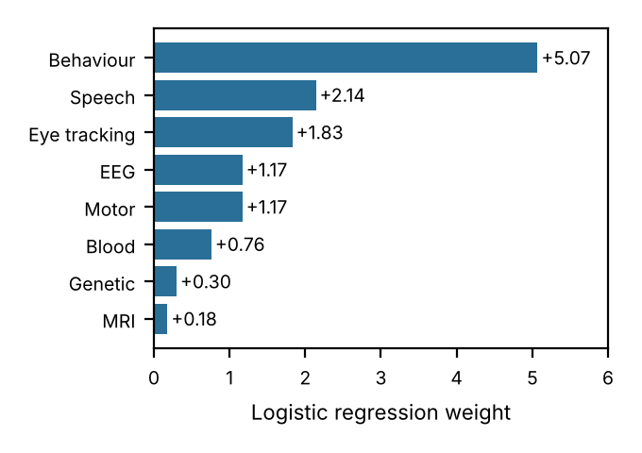
Fig. 2. Learned logistic regression weight for each biomarker module.
V. DISCUSSION
The weighted score ranks children best overall (highest AUC) but is not a calibrated probability, so a fixed 0.60 cut-off is conservative; logistic regression is closer to calibrated and therefore better balanced at that cut-off. With only 90 test children, differences of a few points are within noise. We also found that setting a missing module to 0.5 can steer the decision tree down a path based on a test that was never done, which argues for missing-value-aware training.
Any comparison between our numbers and those in Table I needs care. The studies used different children, different sample sizes and different tasks, and ours uses simulated children, so the accuracy values cannot be lined up directly. What can be compared is what each approach demands. Han et al. show that fusing EEG and eye tracking beats either signal alone [5], but their pipeline needs a high-density EEG cap, a calibrated eye tracker, a controlled room and three trained networks. Ours runs in a browser and works with whatever subset of tests a clinic has, from a questionnaire alone upward.
The two approaches are better seen as complementary. A behavioral model can act as an inexpensive first filter, and children it flags as high risk can be sent on for deeper physiological or clinical assessment.
VI. LIMITATIONS
- All results come from 300 simulated children; the models have not been validated on real clinical data.
- Reference ranges and module weights are placeholders, not age- and sex-specific clinical norms.
- The hold-out set of 90 children is small, and missing modules are imputed as 0.5.
- The model outputs a risk score, not a diagnosis. Any real deployment would need clinical oversight and careful handling of children’s data.
VII. CONCLUSION AND FUTURE WORK
We presented EarlySign, which combines up to eight behavioral and biological biomarker modules into an explainable ASD risk level and compares a weighted score, logistic regression and a decision tree. On 90 held-out simulated children, AUC ranged from 0.851 to 0.892, and logistic regression reached 90.0% accuracy with 100% specificity at the High cut-off. Behaviour, speech and eye tracking carried the most weight, which gives clinicians something concrete to check instead of a black-box score.
The next step is validation on real, consented clinical data with proper age- and sex-specific norms. Motivated by the gains of multimodal fusion [5], we also plan to extract features directly from raw eye-tracking, EEG and audio, to try stronger models such as gradient boosting with calibration, and to run a small pilot with clinicians.
VIII. REFERENCES
[1] American Psychiatric Association, Diagnostic and Statistical Manual of Mental Disorders, 5th ed. Arlington, VA, USA: APA, 2013.
[2] M. J. Maenner et al., “Prevalence and characteristics of autism spectrum disorder among children aged 8 years: ADDM Network, 11 sites, United States, 2020,” MMWR Surveill. Summ., vol. 72, no. 2, pp. 1–14, 2023.
[3] R. P. Goin-Kochel, V. H. Mackintosh, and B. J. Myers, "How many doctors does it take to make an autism spectrum diagnosis?" Autism, vol. 10, no. 5, pp. 439–451, Sep. 2006.
[4] D. L. Robins et al., “Validation of the Modified Checklist for Autism in Toddlers, Revised with Follow-up (M-CHAT-R/F),” Pediatrics, vol. 133, no. 1, pp. 37–45, 2014.
[5] J. Han, G. Jiang, G. Ouyang, and X. Li, "A Multimodal Approach for Identifying Autism Spectrum Disorders in Children," IEEE Trans. Neural Syst. Rehabil. Eng., vol. 30, pp. 2003–2011, 2022, doi: 10.1109/TNSRE.2022.3192431.
[6] T. Wadhera and D. Kakkar, "Social cognition and functional brain network in autism spectrum disorder: Insights from EEG graph-theoretic measures," Biomed. Signal Process. Control, vol. 67, Art. no. 102556, May 2021.
[7] M. Baygin et al., "Automated ASD detection using hybrid deep lightweight features extracted from EEG signals," Comput. Biol. Med., vol. 134, Art. no. 104548, Jul. 2021.
[8] W. Liu, M. Li, and L. Yi, "Identifying children with autism spectrum disorder based on their face processing abnormality: A machine learning framework," Autism Res., vol. 9, pp. 888–898, Aug. 2016.
[9] G. Wan et al., "Applying eye tracking to identify autism spectrum disorder in children," J. Autism Dev. Disord., vol. 49, pp. 209–215, Jan. 2019.
[10] L. Breiman, "Random forests," Mach. Learn., vol. 45, no. 1, pp. 5–32, 2001.
[11] C. Cortes and V. Vapnik, "Support-vector networks," Mach. Learn., vol. 20, no. 3, pp. 273–297, 1995.
[12] T. Chen and C. Guestrin, "XGBoost: A scalable tree boosting system," in Proc. 22nd ACM SIGKDD Int. Conf. Knowl. Discovery Data Mining, 2016, pp. 785–794.
[13] F. Pedregosa et al., "Scikit-learn: Machine learning in Python," J. Mach. Learn. Res., vol. 12, pp. 2825–2830, 2011.

